# Table of Contents

Contents

Table of Contents 1

1. Important Links & Contacts 2

2. Before you update 3

3. Tote Supply conveyor and Tote Slide sensor setup 7

3.1. ASIN Tote Supply conveyor empty and/or Machine Starved warnings on HMI 7

4. Material Setup 8

4.1. SmartPac 3 HMI – view material settings (read only) 8

4.2. SmartPac 5 HMI – view material settings (read only) 8

4.3. PLC g_par’s to adjust material type setting 9

4.4. Kickout “The scanned box barcode is not valid” 10

5. Ultrasonic Sensor Setup 11

5.1. I/O Link version 11

5.1.1. Item Too Large Warning 11

5.1.2. Frequent Flush for tall packages 11

5.2. Ultrasonic sensor version (for 3.x machines) 11

5.3. Ultrasonic sensor version (for 5.3 machines) 12

6. 1.16 - Gripper Adv/Ret Cycle Fault 13

7. HMI not showing data after update 14

8. SmartPac 3 Gripper Servo errors 15

8.1. Overview 15

8.2. Troubleshooting - Do this first! 15

8.3. 0.8 - Gripper Fault Cycle too long or Servo Not Ready - Press Reset - Call Maintenance if Recurring 15

8.4. 1.4 - Gripper Servo Axis Fault - Press Reset - Call Maintenance if Recurring ECode 16 15

8.5. 1.5 - Gripper Servo Down Position Limit Incorrect - Rehome Gripper - Call Maintenance if Recurring 16

# Important Links & Contacts

Master MCM

* <https://mcm.amazon.com/cms/MCM-54257100>

SmartPac 3 wiki

* <https://w.amazon.com/index.php/FCShip/SmartPac>

SmartPac 3 gPar setting

* <https://w.amazon.com/bin/view/FCShip/SmartPac#g_Par_Definitions_.28Machine_Option_Settings.29>

Smartpac 3 code

* https://w.amazon.com/index.php/FCShip/SmartPac#Software_Versions

SmartPac 5 wiki

* <https://w.amazon.com/bin/view/FCShip/SmartPac/Version5_x/>

SmartPac 5 gPar settings

* <https://w.amazon.com/bin/view/FCShip/SmartPac/Version5_x/#Hg_ParDefinitions28MachineOptionSettings29>

SmartPac 5 code

* <https://w.amazon.com/bin/view/FCShip/SmartPac/Version5_x/#HSoftwareVersions>

**Contacts:**

* Venki – venkitac@amazon.com
* Terin – thoterin@amazon.com
* Brian – bkeilly@amazon.com

# Before you update

1. Summary of gripper interlock to light curtain change

* Prevents gripper from closing if light curtain blocked
  + If the light curtain inhibits gripper close for 5 seconds or greater the machine faults
* Prevents **start** of gripper upward movement if light curtain is blocked.
  + This means motion cannot be started.  It is not obvious but there are two upward moves.  The first from below the bag to under the jaw and the second from under the jaw to the bag grab.  Both are independently interlocked to the light curtain
* Will **stop** the gripper upward motion anytime the light curtain is blocked
  + Gripper motion will resume when the light curtain is unblocked
  + If the light curtain inhibits the griper motion for 10 seconds or greater the machine faults

1. What to expect
   1. SmartPac 3
      * (safety) The tamp is interlocked to the light curtain

the printer tamp head will stop motion if the light curtain is broken during its motion. Under normal circumstances the tamp will resume operation after the light curtain is unblocked. If the light curtain remains blocked for too long a fault will occur

* + - (safety) Jaw interference faults (light curtain blocked during jaw closure or jaw close fault)

Because these are safety faults a manual reset is required.

* + - (safety) Gripper upward and grip finger close interlocked to light curtain

To prevent hitting an associate during induct the gripper upward motion is stopped and/or the gripper fingers are prevented from closing when the light curtain is interrupted. Under normal circumstances the gripper will resume operation after the light curtain is unblocked. If the light curtain remains blocked for too long a fault will occur

* + - Material Types

The machine now supports multiple material types with specialized configurations for each type

* + - Gripper advance/retract issues

Some previous versions of code had the gripper advanced sensors (move right) removed from the code. This is not ideal because the sensor is used to prevent the gripper hitting the jaw. The ideal solution is to repair the sensor. If repairing will substantially delay implementation then g_par.24 may be used to enable an operational mode that does not use the sensor

* + - Gripper servo issues

Implementation of 3 bag has surfaced issues with the gripper servo control. To mitigate these issues and standardize operation, and therefore repair, the servo control is more sensitive than it was before. Soft limits are controlled to prevent hitting of hard stops and lower position deviations outside of acceptable limits are detected. More details in the servo section. Be advised that maintenance and/or repair of the gripper drive system may be required to eliminate servo errors.

* 1. SmartPac 5
     + (safety) Gripper upward and grip finger close interlocked to light curtain

To prevent hitting an associate during induct the gripper upward motion is stopped and/or the gripper fingers are prevented from closing when the light curtain is interrupted. Under normal circumstances the gripper will resume operation after the light curtain is unblocked. If the light curtain remains blocked for too long a fault will occur

* + - Material Types

The machine now supports multiple material types with specialized configurations for each type

1. SmartPac 3
   1. **STOP** if your machines had not been upgraded to 3 Bag Monet
2. SmartPac 5
   1. Identify the version of code you are running
      * SmartPac5_v32_SS1b3B11_xxxx_xx_xx
        1. Requires “SmartPac5_v32_GrpFix10” code
      * SmartPac5_v32_AC73bB11_xxxx_xx_xx
        1. Requires “SmartPac5_v32_AC73bB11” code
      * Any other versions
        1. Reach out to Venki, Terin or Brian for direction
3. Run machine for 15 minutes with production associate
   1. Note rate and performance
   2. Correct any maintenance issues found
   3. **STOP** if machine has operational or maintenance issues that cannot be resolved before upgrade
4. Backup current PLC and HMI code
5. Record all current g_par values
   1. Compare current values to the wiki:
      * SmartPac 3 <https://w.amazon.com/bin/view/FCShip/SmartPac#g_Par_Definitions_.28Machine_Option_Settings.29>
      * SmartPac 5 <https://w.amazon.com/bin/view/FCShip/SmartPac/Version5_x/#Hg_ParDefinitions28MachineOptionSettings29>
   2. Determine your setup
      * SmartPac 3
        1. **note**: g_par.2 downstream interlock - is no longer user controlled and is inverted from previous
        2. **note**: g_par.4 landscape printer - is no longer used
        3. **note**: g_par.5 OEE starved - is no longer user controlled and is inverted from previous
        4. **note**: g_par.7 allows Slide Tote sensor mode selection
           1. ***see section 3. Tote Supply conveyor and Tote Slide sensor setup***
        5. **note**: g_par.8 allows Conveyor Tote sensor mode selection
           1. ***see section 3. Tote Supply conveyor and Tote Slide sensor setup***
        6. **note**: g_par.13 – 17 & g_par.20 – 23 are material type selection (see below)
           1. ***see section 4. Material Setup***
        7. **note**: g_par.18 selects Ultrasonic version (see below)
           1. ***see section 5. Ultrasonic Sensor Setup***
        8. **note**: g_par.24 selects use or non-use of gripper advanced sensor (see below)
           1. ***see section 6. 1.16 - Gripper Adv/Ret Cycle Fault***
      * SmartPac 5
        1. **note**: g_par.3 allows Conveyor Tote sensor mode selection
           1. ***see section 3. Tote Supply conveyor and Tote Slide sensor setup***
        2. **note**: g_par.4 allows Slide Tote sensor mode selection
           1. ***see section 3. Tote Supply conveyor and Tote Slide sensor setup***
        3. **note**: g_par.5 OEE starved - is no longer user controlled
        4. **note**: g_par.7 downstream interlock - is no longer user controlled
        5. **note**: g_par.13 – 17 & g_par.20 – 23 are material type selection (see below)
           1. ***see section 4. Material Setup***
        6. **note**: g_par.18 selects Ultrasonic version (see below)
           1. ***see section 5. Ultrasonic Sensor Setup***
        7. **note**: g_par.19 Nip roller rotate forward or reverse
           1. ON machines built prior to 2021
           2. OFF machines built in or after 2021
6. Upload the new version of PLC and HMI code
7. Setup the machine specific g_par’s
8. Setup the machine specific HMI settings

# Tote Supply conveyor and Tote Slide sensor setup

## ASIN Tote Supply conveyor empty and/or Machine Starved warnings on HMI

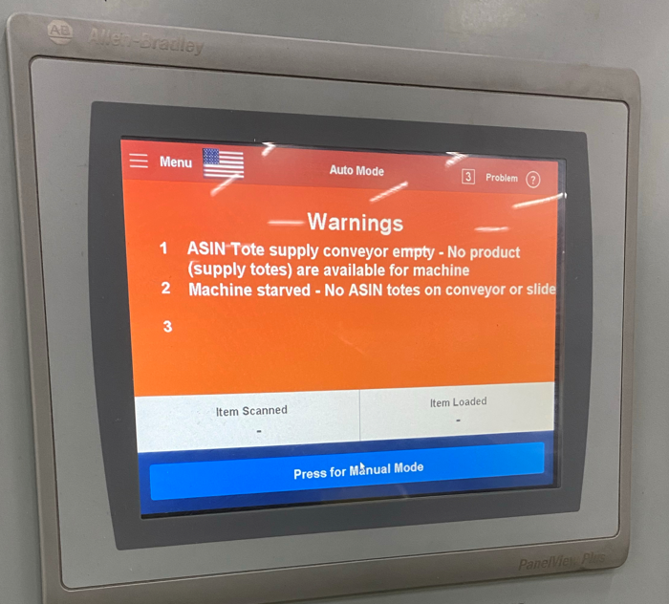

This is likely due to sensors being light activated vs dark activated.

* gPar.7 and gPar.8 allow inverting the sensor if needed. <https://w.amazon.com/index.php/FCShip/SmartPac#g_Par_Definitions_.28Machine_Option_Settings.29>
* Setup Information

<https://w.amazon.com/index.php/FCShip/SmartPac#OEE_Starved_Condition_Definition>

# Material Setup

Check the configuration on the HMI

* only one (1) box should be green
* options are read-only – changes must be made through the PLC as noted further down

### SmartPac 3 HMI – view material settings (read only)

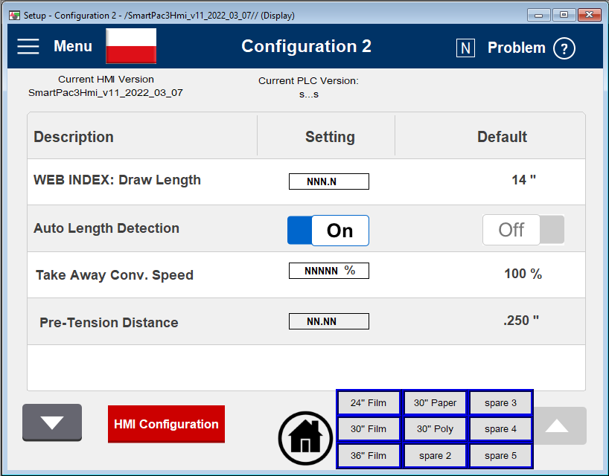

### SmartPac 5 HMI – view material settings (read only)

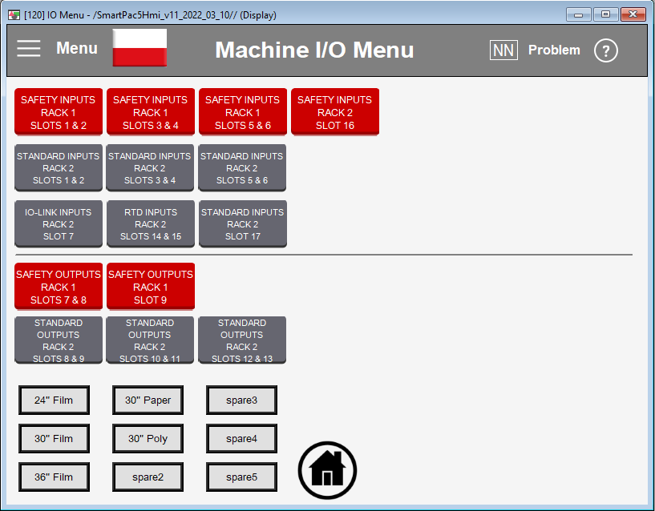

## PLC g_par’s to adjust material type setting

Only the config for the material you are running should be active (ON). Typically, this is g_par_FilmWidth30in as shown in the screen shot below

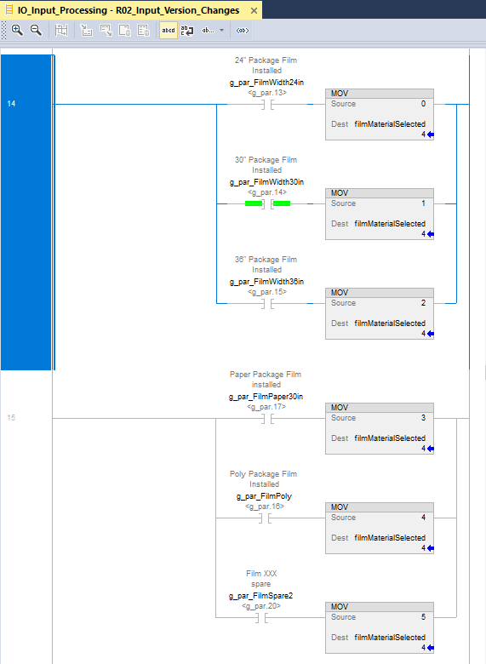

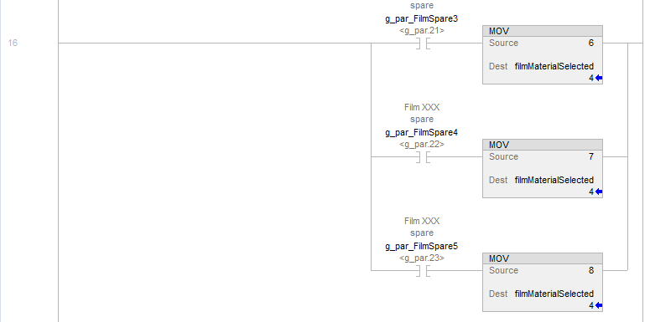

## Kickout “The scanned box barcode is not valid”

The following kick out can occur if the material type is not properly setup

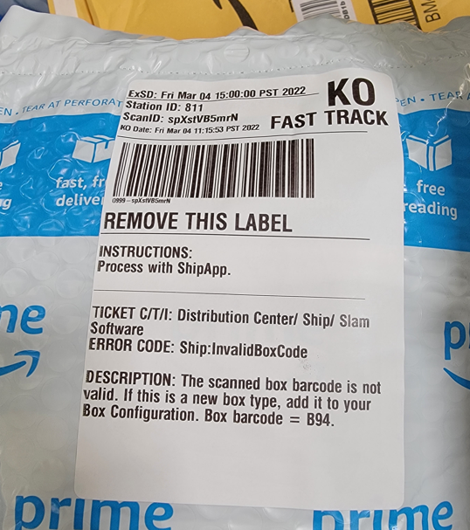

# Ultrasonic Sensor Setup

## I/O Link version

### Item Too Large Warning

### Frequent Flush for tall packages

* Visually verify ultrasonic sensor version – sensors are under cover above induct pocket
* Set g_par.18 to match the sensor version
  + IO Link 1.0
    - If sensor model numbers are Pico+25/WK/F, Pico+35/WK/F
    - g_par.18 ON (1)
  + IO Link 1.1
    - If sensor model numbers are Pico+25/WK/F/A or Pico+25/F/A; Pico+35/WK/F/A or Pico+35/F/A
    - g_par.18 OFF (0)

See section 5.2 for SmartPac 3.x machines and section 5.3 for SmartPac 5.3 machines

# 

## Ultrasonic sensor version (for 3.x machines)

Toggle the g_par bit to indicate the IO Link version of ultrasonic sensor installed on the machine (g_par.18)

IO Link version 1.0 – Pico+25/WK/F, Pico+35/WK/F

IO Link version 1.1 – Pico+25/WK/F/A, Pico+35/WK/F/A

Front sensor model number (close to operator) : Pico+25/WK/F Rear sensor model number (away from operator): Pico+35/WK/F - IO Link version 1.0 **(g_par.18 ON)**

Front sensor model number (close to operator): Pico+25/WK/F/A Rear sensor model number (away from operator): Pico+35/WK/F/A – IO Link version 1.1 **(g_par.18 OFF)**

Note sensors have to be either both IO Link version 1.0 or both IO Link version 1.1.

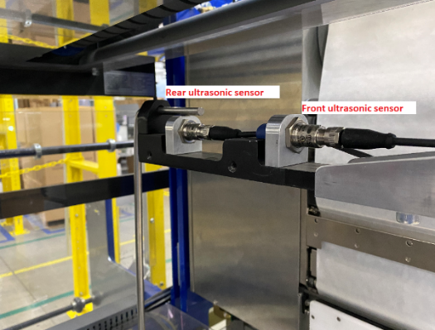

## Ultrasonic sensor version (for 5.3 machines)

5.3 machines should be running IO Link version 1.1 sensors.

* IO Link version 1.1 **(g_par.18 OFF)**
* Front sensor model number (close to operator): Pico+25/WK/F/A or Pico+25/F/A
* Rear sensor model number (away from operator): Pico+35/WK/F/A or Pico+35/F/A

# 1.16 - Gripper Adv/Ret Cycle Fault

* Indicates the gripper advance (move to right) cylinder advance reed switch is not working
* It is suggested that this sensor be repaired
* If you choose not to repair the sensor, enable g_par.24

# HMI not showing data after update

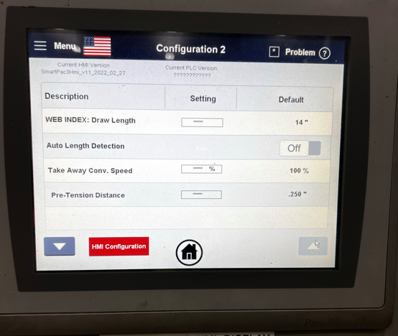

Update HMI firmware

<https://drive.corp.amazon.com/folders/SmartPac/Code%20Repository/02_HMI%20Code/SmartPac%203.x/firmware>

# SmartPac 3 Gripper Servo errors

## Overview

* The gripper maximum up position and down position are detected by resistance (this has always been the functionality). The gripper moves up until it hits the physical limit, as detected by current. The same process is used for the maximum lower position
* The soft limits are set 0.15” inside the maximum up and maximum down position
  + Because of this, lash or excess resistance in the gripper drive system can cause the servo to overshoot tripping a limit
* The gripper position is being more rigidly checked to ensure consist 3 bag sizes and to correct problems found in the field
  + Gripper not dropping low enough and tearing long bags
  + Gripper not dropping low enough and causing tall items to be crushed in the jaw
  + Gripper hitting the jaw
  + Gripper hitting hard stops

## Troubleshooting - Do this first!

* Set pre-tension to zero (0) – this is a temporary change to identify if pre-tension is pulling the gripper mechanicals out of alignment with the servo position which indicates excessive lash in the mechanical system.
* If setting pre-tension to zero (0) resolves your issues it indicates too much lash in the gripper drive mechanism.

## 0.8 - Gripper Fault Cycle too long or Servo Not Ready - Press Reset - Call Maintenance if Recurring

* For first occurrence press the e-stop under the HMI and then retry
* If the problem is repetitive it is typically occurs because the gripper failed to find the home sensor

## 1.4 - Gripper Servo Axis Fault - Press Reset - Call Maintenance if Recurring ECode 16

* Typically this is due to mechanical issues in the gripper drive.
  + Ensure all gripper components are tightly affixed
  + Ensure gripper belt tension is correct
  + Ensure gripper motion is smooth with low resistance from top to bottom
  + Ensure gripper home and overtravel sensors are firm and triggering properly

## 1.5 - Gripper Servo Down Position Limit Incorrect - Rehome Gripper - Call Maintenance if Recurring

* Typically caused by something obstructing detection of the lower limit
  + Check for packages and/or package material prevent the gripper from going all the way down to the mechanical limit
  + Check for mechanical issue preventing the gripper from going all the way down to the mechanical limit
  + Check for mechanical resistance near the mechanical limit